**Name: G. Bhuvana Chandrika**

**Trainer Name: Harshee Pitroda**

**Course Name: Python & machine Learning Basics**

**Date:24/06/2022**

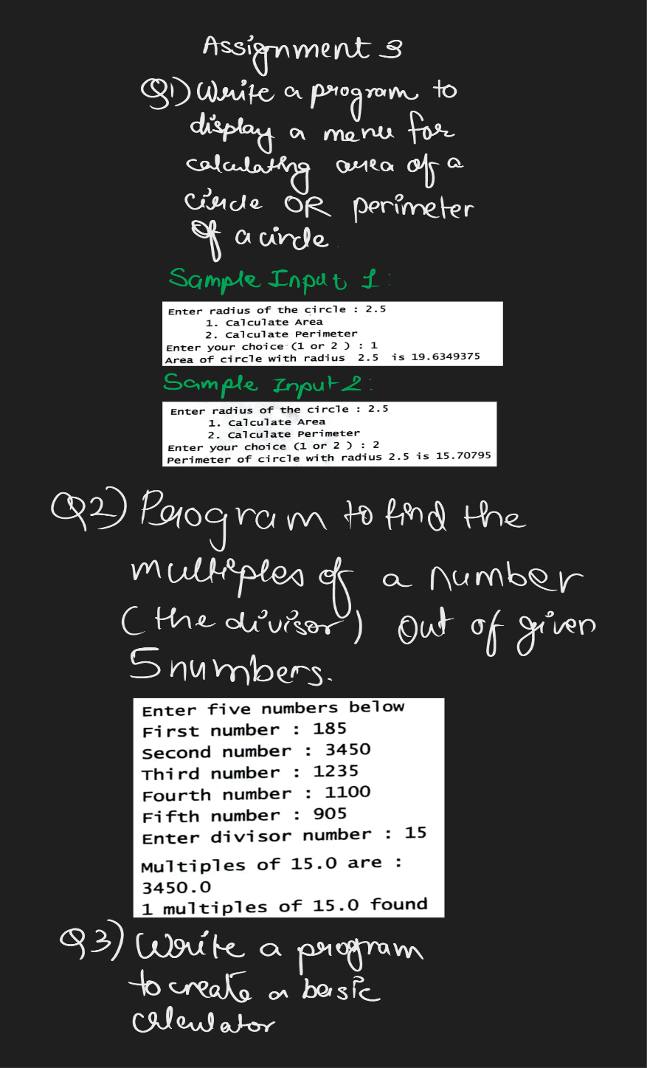

**1)**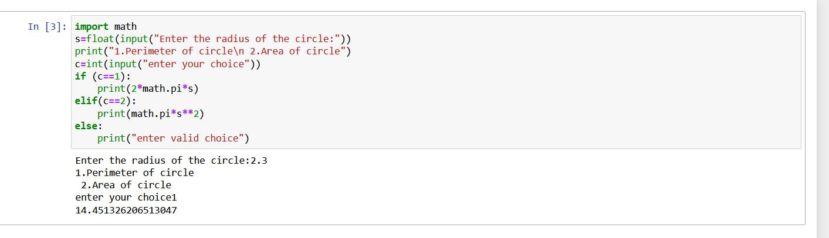

**2)**

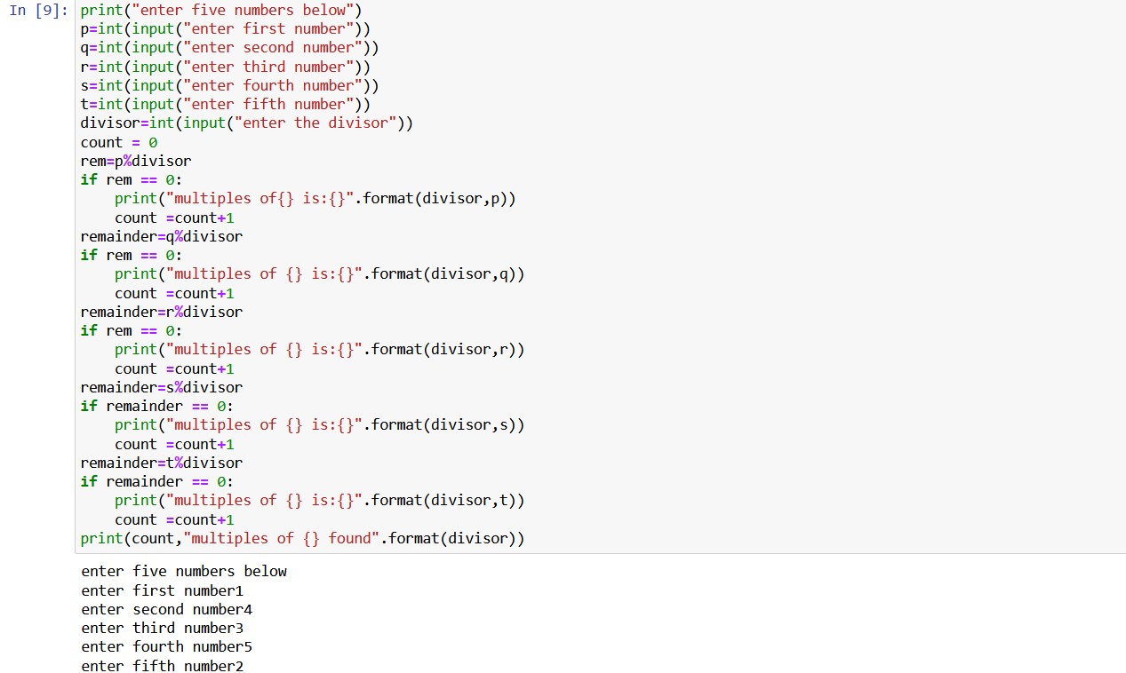 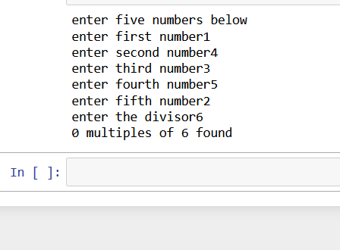

3) 